NATIONAL ASSOCIATION
FOR INTERPRETATION

Community Procedures Manual

Community Requirements
From the NAI Bylaws:
Section 9.2 Community Officers
Each Community shall, in accordance with the procedures established by the Board of
Directors, elect a Director, a Deputy Director, Treasurer and such other officers as the members of the Community deem necessary and appropriate, each of whom must be a member of NAI. The duties and functions of the Director and Deputy Director shall be determined by the Board of Directors, and the duties and functions of all other officers shall be determined by the members of the Community. Unless otherwise restricted by statute, the Articles of Incorporation, Constitution, or these Bylaws, a Community officer may be removed from office, or vacancies may be filled, according to the procedures established by the Advisory Council and approved by the Board of Directors.

From the Advisory Council Manual:
The Advisory Council will follow the NAI Constitution and By-Laws regarding policies and procedures. This manual is meant to cover the basic operational procedures.

All new Communities must meet the following criteria to be recognized by the Board of
Directors and hold a seat on the Advisory Council. Any reorganization of an existing Community will follow this same criteria.

- Have planning documentation stating
- 50 members the new Community will be serving, showing an existing interest within this membership.
b. The specific (minimum) member services the Community will be offering
c. Leadership structure of the Community including individuals that will serve as Interim officers until formal elections are held.
d. Startup financial needs (if any)
e. Evaluation criteria – to be used in annual member service reviews
f. Timeline for operations manual and the start of member services being provided.

- Hold elections of leadership positions consistent with all NAI election policies during the next NAI election cycle.

How to maintain a Community in good standing
There are three requirements that each Community must have to maintain status as a recognized Community within NAI
- Current NAI member in good standing holds each of the elected positions. (Director, Deputy Director, Treasurer, Secretary or a combined Treasurer/Secretary)
- A budget submitted to the Advisory Council by March 1 each year for the upcoming fiscal year.
- Evaluation of Core Services submitted to Advisory Council by the due date of March 1 each year.

Budgets
Budget information is due to the Advisory Council Finance Chair on the due date of March 1 in order to implement the new budget for the following year. All Communities should operate on a zero balance budget. More information on budgets is available on the NAI website under Resources > NAI Administrative Documents > Manuals, Policy and Forms or Resources > NAI Administrative Documents > NAI Communities Resources.

Community Core Services
NAI Members join Communities for regional or special specific services. Core Services are the main services leaders of each Community promise to provide to members of that Community. This creates a standard to measure success in delivery of both in quantity and quality of service.

What is a Core Service?
Core Services are the most important services that the community can provide for its members. A Core Service is a “must have” service that a Community provides to the members of that Community. Without this service, it would negatively impact the Community. Each Community may provide additional services for their Community.

A Core Service spreadsheet template is available for leaders to create a Community Core Service plan. The following items are important when establishing a Core Service plan:
- Core Service – name the service the Community will provide to members
- Goal – what the Community is trying to achieve with this service
- How You Will Achieve This Goal – list the specific means of achieving the goal
- What Success Looks Like – list a measurable way to count the goal
- Current Success Rate – update as to where you are with your goal
- How goal relates to the NAI Strategic Plan
- Narrative – area reserved for comments on success and challenges for the services offered that year
Changing Core Services
Core Services are submitted to and approved by the Advisory Council on an annual basis. The Advisory Council Chair and Vice Chair review the Core Services. If a Community is not in compliance, the AC Chair and Vice Chair can work with the Community or assign a mentor to work with the Community to get them into compliance. The AC Chair and Vice Chair will notify the Board of Directors if any Community is not in compliance and efforts to correct the situation. Any Community not in compliance is at risk of being eliminated if it cannot deliver the Core Services promised to members. Any changes to Core Services must be submitted to the Advisory Council representatives who will then present to the Board of Directors for approval. Core Services must align with NAI’s strategic plan to ensure appropriate steps towards the Association’s goals.
Deadlines for Core Services
NAI Advisory Council sets the deadlines for Community Core Service dates due to the council. It is recommended that Communities review Core Services at the beginning of each year with leadership teams, track progress throughout the year and update as needed. Completed Core Service spreadsheets are due to the Advisory Council Chair on March 1 of each year on the progress of the previous 12 months.

Community Mentors
When a Community is developing or struggling to maintain the minimum requirements, Leadership from the Community will be assigned a mentor from the Advisory Council to assist the Community with meeting requirements and building the strength of the Community.

Nominations and Elections
Elections for Community officers are held in conjunction with the National election in September. Nominations are due to the Advisory Council’s Elections & Nominations chair by August 15 in order to be included in the ballot. All nominees must be current NAI members. Elections will follow NAI’s Nominations & Elections Manual. A Community is required to have as at a minimum, a Director, Deputy Director, and Treasurer. Most communities also elect a Secretary or a joint position of Secretary-Treasurer as an officer position.
Community Policies Established by the National Organization and Advisory Council
Complimentary Memberships
A Community Director has the authority to award up to two complimentary memberships annually to new members. The funding for these memberships is supplied by the National operating budget.

Ethics & Conflict of Interest Policy
Members of the Community Executive Committee, Chairs of standing committees, and representatives for States or Chapters are required to sign the NAI Code of Ethics annually and be familiar with the NAI Conflict of Interest Policy. Downloadable forms are available on the NAI website under Resources > NAI Administrative Documents > Manuals, Policy and Forms. This includes the Community Director, Deputy Director, Treasurer, Secretary and Publications (Newsletter) Chair and all voluntary Community leadership positions. These forms are due to NAI Deputy Director by February 1.

Location of Community Funds
All Community funds will be maintained in checking and/or savings accounts held by the National Organization to meet non-profit status requirements of the IRS. Access to those funds is by submission of the NAI Disbursement form available on the NAI website under Resources > NAI Administrative Documents > NAI Communities Resources or in specific instances with prior arrangement through the NAI credit card.

NAI Logo Use
All NAI National and Community endorsement of events, services, or products (which are not internally generated programs) must have prior review and approval by NAI’s Deputy Director/Advisory Council liaison. The NAI graphics standards manual should be consulted for correct and appropriate use of the logo. It can be found on the NAI website on the Resources Tab, under NAI Administrative Documents. The NAI Deputy Director is responsible for monitoring the logo usage. All Community correspondence, newsletter, meeting announcements and publications must include the complete logo. However, individualized logos and designs that would represent any of these groupings are encouraged and may be used in conjunction with the National logos. The Advisory Council shall monitor this use.

Naming Policy
A group of members may petition the Board of Directors to rename a recognized Community at any of the Board of Directors Regular Board Meetings, by:
- Provide written documentation showing how the proposed Community changes have been vetted by the elected officials and membership of the Community at-large
- Provide written documentation showing support for the change by NAI staff managing the “NAI Identity and Graphics Standards”.
- Name changes depicting or including content which is derogatory, offensive, threatening, indecent, sexually explicit, obscene, violent, profane, discriminatory in any way, or that promotes hatred or harm against any group or person, as determined by the National Association for Interpretation in its sole discretion, shall be disqualified.

National Awards
No member is eligible to receive any national award in one category more than once with the exception of the Meritorious Service Award. Members through the Community Director's complimentary membership program are not eligible for these awards, but may be nominated for Honorary Membership, Meritorious Service, or Special awards.

Official NAI Position Requests
The NAI Board as a whole can be petitioned to take a position that will not threaten the
Organization’s 501(c)3 status. The nature of our non-profit status precludes lobbying as a function of our organization. NAI’s 501(c)3 documentation can be found on the NAI website under Resources > NAI Administrative Documents > Financial Information.

Scholarship, Professional Grants and Grants Policy
The Scholarship, Professional Grants, Grants Policy for National Association for Interpretation is available on interpnet.com in the Manuals, Forms, and Policies section. For the National Conference, all scholarship recipient information is due to the National Organization by August 1 for early registration prices and October 1 for regular registration prices.

Community Officers and Committee Chairs
Position Descriptions for Community Officers
The Director, Deputy Director, Treasurer, and Secretary all are elected by the voting members of the region for up to two three-year terms, and as such form the Executive Committee of the Region’s governance. All must work within the parameters of the Bylaws established by the National Association for Interpretation as stated in Article VII.

The chain of command for officers is listed below. When one officer is not available for a meeting or has resigned; then the task rotates to the following officer. The Director may appoint, until the next election, members to fill vacancies created by the departure of an officer. If the Director's position is vacated, the sequence of succession shall be Deputy Director, Treasurer, and then Secretary (Bylaws for The National Association for Interpretation). All officers must annually file a signed NAI Ethics form with the National Office.

All Community officers are expected to serve as mentors to their successors by providing records, information, and helpful advice on conducting the responsibilities required by the role.

Director
The Community Director plays a critical role in helping the National Association for Interpretation achieve its vision, mission, and goals by delivering exceptional member services and professional development. The Director is responsible for all community operations via its leadership team. S/he is accountable to NAI's National Board via the Advisory Council. The Director is instrumental in ensuring consistent and effective internal processes and communications in order to strengthen NAI's nonprofit programs and position the organization for continued success.

Term
This volunteer position is elected for a three-year term by the Community’s general membership.

Duties
- Create and implement strategic and operational plans for the Community’s continued growth and development.
- Ensure Community activities and member services are aligned with NAI's vision, mission, and goals and incompliance with its bylaws, operation manuals, and guidelines.
- Manage and develop Community officers and chairs.
- Manage and control Community expenditures within agreed budgets by reviewing quarterly and year-end finance reports
- Attend and lead the annual Community meeting, scheduled during the National Conference.
- Attend Advisory Council meetings and represent the Community members’ interests.
- Maintain awareness and knowledge of Advisory Council policies/procedures and provide suitable interpretation to the Community leadership team and its general members.
- Monitor, measure, and report on Community development plans, performance, and achievements within agreed formats and timescales as defined by the Advisory Council.
- Ensure all deadlines are met: core services, budget, etc.

Time Obligations
Varies depending on the time of year, activities, and any additional roles or committees assumed. Estimated average time is five hours per week.

Minimum Requirements
Must be a current NAI member and member of the Community.

Preferred Qualifications
- Personal qualities of integrity, credibility, and a commitment to NAI's vision, mission, and goals.
- Previous experience as a Community officer.
- A successful track record in setting priorities, shaping processes, guiding investment in people, and developing an infrastructure that creates a stronger and more efficient organization.
- Thorough understanding of project management, as well as an ability to work effectively under pressure to meet tight deadlines and goals.
- A team leader with a flexible and creative approach.
- Excellent communication and coalition building skills with an ability to balance, negotiate, and work with a variety of internal and external stakeholders.
- High level of knowledge and understanding, especially as it relates to professional development, connecting programs to funding, creatively generating other resources, and building strategic partnerships.
- Excellent verbal and written communication skills with exceptional attention to details.
- Proficient use of technology as a management reporting tool and an ability to develop and implement effective program evaluations.

Deputy Director
The Deputy Director will play a critical role in helping the National Association for Interpretation achieve its vision, mission, and goals by delivering exceptional member services and professional development. The Deputy Director is a voting officer and will be directly responsible for Community chairs. S/he will be accountable to the Community Director. This position will be instrumental in ensuring consistent and effective internal processes and communications in order to strengthen NAI's nonprofit programs and position the organization for continued success.

Term
This volunteer position is elected for a three-year term by the Community’s general membership.

Duties
- Participate in quarterly and as-needed meetings with the Community Leadership Team.
- Oversee Community’s Leadership Team Chair positions such as Workshop Chair, Scholarship Chair, and Awards Chair, and assist Chairs with assignments as needed.
- Assist Community Director by ensuring Community core member services are met in accordance to Advisory Council’s Community Core Services Evaluation Form.
- Assume Interim Community Director Role if Director cannot fulfill term.
- Attend Advisory Council meetings if the Director cannot fulfill this commitment.
- Other duties as assigned by Community Director.

Minimum Requirements
Must be a current NAI member and member of the Community.

Preferred Qualifications
- Personal qualities of integrity, credibility, and a commitment to NAI’s vision, mission and goals.
- A successful track record in setting priorities, shaping processes, guiding and investment in people, and developing an infrastructure that creates a stronger and more efficient organization.
- Commitment to professional development and networking of Community members via conferences and other creative methods.

Time Obligations
Varies based on activities. On average, approximately 2-4 hours monthly

Treasurer/ Secretary
The Community can have these duties separate and held by two people, but in the case of a Community not being able to find enough volunteers to fill the roles separately, they can be combined. The Treasurer/ Secretary will play a critical role in helping the National Association for Interpretation achieve its vision, mission, and goals by delivering exceptional member services and professional development. The Treasurer/ Secretary is a voting officer. S/he will be accountable to the Community Director. This position will be instrumental in ensuring consistent and effective internal processes and communications in order to strengthen NAI's nonprofit programs and position the organization for continued success.

Term
This volunteer position is elected for a three-year term by the Community’s general membership.

Duties

Treasurer
- Guide the leadership team to develop, prepare, and approve the Community’s annual budget.
- Compare the actual revenues and expenses incurred against the budget for each quarter.
- Ensure the Community remains in compliance with NAI's financial policies and guidelines.
- Approve and complete Community transactions, as well as required financial reporting forms in a timely fashion.
- Keep the Community Leadership Team regularly informed of key financial events, trends and concerns.
- Provide annual financial reports to the members at the Community meeting.
- Other duties as assigned by the Director.

Secretary
- Arrange, participate in, and record minutes for various meetings, conferences, and Community activities.
- Maintain the Community’s policy manual and Book of Motions.

Time Obligations
Varies depending on the time of year, section activities, and any additional roles or committees assumed. Estimated average time is 2-4 hours per month.

Minimum Requirements
Must be a current NAI member and member of the Community.

Preferred Qualifications
- Excellent communication skills, both verbal and written.
- Knowledge of and ability to use a variety of software, such as the Microsoft Office Suite.
- Ability to manage paper and electronic files, as well as a member database.
- Keen financial understanding and experience developing and balancing budgets.
- Previous experience, with working knowledge of Robert's Rules of Order

Position Descriptions for Committee Chairs
Each Community can determine what committee chairs are beneficial to their unit. Below are listed some of the common committee chair positions and a description of duties, A Community is not limited to these positions and any of these positions descriptions can be altered to meet the needs of the Community. These positions are not elected positions. They can be volunteered for or filled by appointment from the Community Director. Minimum requirement is they must be a current member of the Community.

Newsletter Editor
Purpose: The Newsletter Editor is responsible for producing and distributing a quarterly newsletter on time. The Editor will work with NAI Staff to distribute the newsletter or through the process that the Community has developed for disbursement.
Responsibilities may include, but are not limited to, the following duties:
- Soliciting articles, photos, art work, and other information for newsletters.
- Participating in meetings as called by the Community Director.
- The Newsletter Editor keeps in contact with the Community Director about each issue to coordinate and to ensure all Community information is included in each newsletter.
- Other duties as assigned by the Community Director.

Scholarships Committee Chairperson
Purpose: The Scholarships Committee provides assistance to undergraduate and/or graduate students, and professionals in a career in interpretation or environmental education through scholarship money as budgeted by each Community. The Chairperson for the scholarship committee is responsible for the overall coordination and direction of the scholarship program. The Chairperson reports to the Treasurer. In the case of the same person serving as Treasurer and Scholarship Chair, they report to the Director of the Community.
Responsibilities may include, but are not limited to, the following duties:
- Create, publicize, and promote a scholarship application process
- Seek and secure at least three Community members to serve on the committee.
- Using the budgetary funding amount provided by the Community Board, determine the categories, quantity, and dollar amount of awards.
- Send an electronic confirmation receipt to all applicants. Forward evaluation forms and copies of all applications to the committee members, and advise them of the deadline(s) to review the applicants.
- After the recipient selection(s) notify all applicants of the results and provide similar information to the Community Director.
- Contact the successful recipients and inform them of any specific requirements and/or expectations during the workshop or conference in order for them to receive the full scholarship amount.
- Conform to the NAI Scholarship Policy and assist the Community Treasurer with filing the required disbursement with the national office.

Awards Committee Chairperson
Purpose: The Community Awards program is designed to recognize outstanding achievements and showcases the success of the Community’s members who work to advance the profession of interpretation. The Awards Chair is responsible for the overall coordination and direction of the awards program.
Responsibilities may include, but are not limited to, the following duties:
- Promote, publicize, and encourage Community members to nominate worthy candidates for Community awards program.
- Seek and secure at least three Community members to serve on the committee.
- Distribute all nomination forms to committee members for review. Create scoring
system for selection of winners.
- Obtain award plaques for presentation at Community workshop and present awards at Community workshop.
- Contact award winners upon selection and encourage attendance at the Community workshop.
- Submit qualifying Community award winners to national awards committee for consideration for National awards as appropriate through the National Awards process.

Membership Services Chairperson
Purpose: This position serves the membership by welcoming new and renewing members and encouraging expired member renewal.
Responsibilities may include, but are not limited to, the following duties:
- Coordinate efforts with the National Organization’s Membership Manager.
- Welcome new members
- Solicit ideas for maintaining contact with members and seeking out new members from all membership services committee members.
- Develop and maintain new member recruitment and sustainability plan.
- Coordinate membership efforts between other Communities
- Maintain regular contact with Community Director
- Participate in Community board meetings as requested.

Community, State, Province, or Area Representatives
Purpose
State, area, and/or provincial coordinators serve as ambassadors between the Community membership and the Community Leadership Team. This position serves the membership by acting as an informational and motivational voice, not only to inform members of community happenings, but to also encourage involvement by members within Community events, committee projects, and various other tasks. The Director may select and appoint them or they may respond to requests for volunteers posted on Community websites or newsletters. Having a roles and responsibilities sheet that outlines the expectations of this position, and the relative amount of time required to live up to this commitment is key to the success of this position.

Responsibilities may include, but are not limited to, the following duties:
- Submit quarterly articles to the newsletter editor of news and events in the state, province, territory, or area.
- Act as a liaison between the Community Leadership Team and its members.
- Participate in Community Leadership Team meetings as requested.
- Recruit a Workshop Chair when a Community workshop is being held in the respective state, province, territory, or area.
- Provide a verbal or written report of state, province, territory, or area news and information at Community and national membership meetings.

A Community is not limited to these representative positions and any of these responsibilities can be altered to meet the needs of the Community.

Community Records, Archives
NAI Communities may choose to make past budgets, workshop manuals, and other documents available as a reference for other Communities. These documents are kept on the NAI website under “My Account.” All Community Officers will have access to an InterpNet Community (not to be confused with an NAI Community—this is part of the website where documents are stored) called “Advisory Council,” which contains a folder called “Resource Library.”
Community Dashboards on InterpNet
NAI Community Officers will all have access to the dashboard for their given Community. It is recommended that the Community newsletter editor and membership chairs (if you have them) have access to this information as well, so that those individuals do not have to contact the Director to get materials sent out (speeding up the process greatly). Some of these individuals may already have access to the dashboards, depending on what you have already set up. You will be able to see on the dashboard who has access to the information.
NAI Board Members (and anyone with Community level benefits) will have access to a dashboard with current counts for Communities and national membership as well as directories of all Community Leadership.
Finding the Dashboards
Visit www.interpnet.com and click the Log On link at the top of the page.

Once you are logged in, hover over the Membership tab at the top of the page. You will see the Dashboard for the Community listed in the menu. Click there to access your Dashboard.
On the Dashboard page you will find basic information and access to the Membership database. Your leadership team is listed along with their term end date. There is also a list of who currently has access to your dashboard. If you need to add or subtract members from this list contact NAI Membership Manager Jamie King.
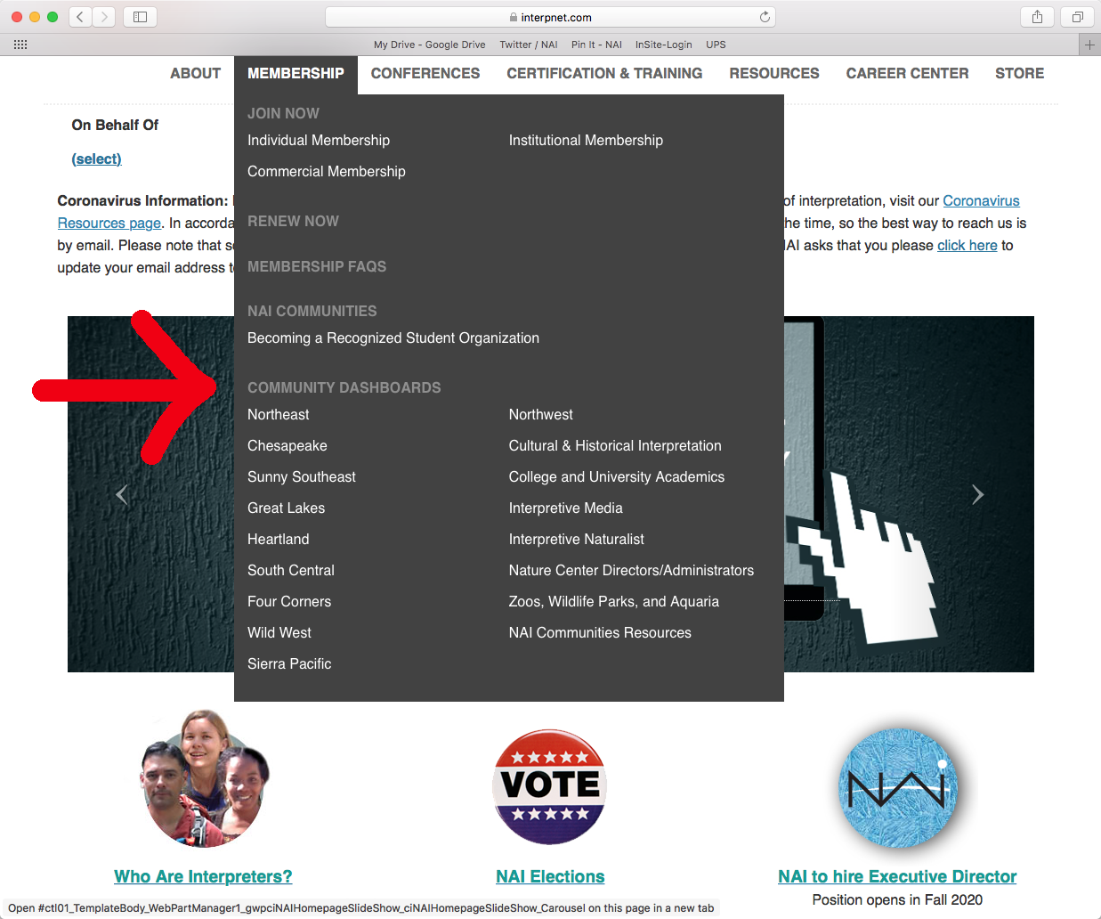

Other resources you can access on this page are the Finances and Accounting Webinar, the most current financials and your Community membership account. In the right hand column, you may also see access to your Community’s current workshop dashboard if it’s applicable to your role in the Community.
How current is the information on the dashboards? The dashboards are tied directly to the membership database so they are completely accurate and up-to-date with what is in the membership database.
Search Results: When you search using the queries for your Community it is likely that you are going to come up with more than 500 results. The website will only show you the first 500 results in the HTML version of the results. To pull a full results list you will need to download the list on to your computer (see Downloading Data).
Downloading Data: To download data from any of the queries, you will want to use the icons below to open the information in working files on your computer.

The icons from left to right are: Word Document, Excel Spreadsheet (Recommended), PDF, Comma Delineated Files, XML File.
If you hover your mouse over the icon it will give you information about the action the icon performs.
You cannot copy and paste directly from the website and not all information will appear on the HTML version of the queries.
Your NAI Membership: If your NAI membership lapses, so will your access to the dashboards. The system is set to only show this information to current NAI members
How to use the Dashboards
There are six options in the pulldown menu. Each one will provide you with different information.
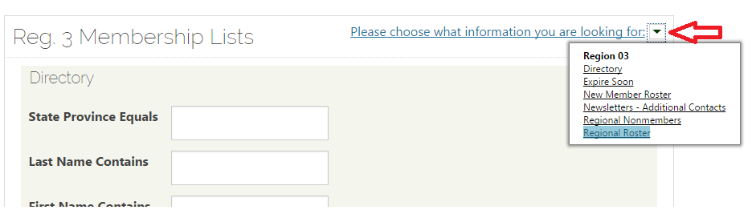
Directory The directory is useful if you are looking for contact information on a specific member.
Expire Soon This pulls up a date range menu that you can set to get a list of members that will expire in that set range. The next option works in the same way, but is set up for pulling lists of
New Members. Both of these queries are useful for communicating with members about their membership, whether welcoming them or reminding them that they are close to expiring.
Newsletter - Additional Contacts If your Community sends out its own newsletter (meaning it is not sent out by the National Office), these are additional NAI members who should be included in your newsletter mailing list. These people include staff and other leaders within NAI.
Regional Non-members The fifth option (which only applies to Regions) is a roster of all contacts in the database who are expired members, but have an address that is in your Region. This list can be very helpful when promoting Regional workshops or other events.
Region Roster/Section Roster The roster options gives you a list of all members in your Community. The HTML list only gives the first 500 and cannot be manipulated. You must download it into one of the forms listed above. Excel is highly recommended.
Advisory Council
The Directors of the Communities make up the Advisory Council. Each year, the full Council elects an Advisory Council Chair, Advisory Council Vice Chair, Financial Coordinator, Secretary, Program Chair, and Elections Coordinator. These six positions make up the Advisory Council Leadership Team. The Chair and Vice Chair represent the Communities on the National Board of Directors and once elected, serve a three-year term on the National Board.

Who to Contact:
Questions about Community procedures, protocols: NAI Deputy Director, Advisory Council Chair, Vice Chair
Questions about Community budgets, expenses, revenue: Advisory Council Financial Coordinator
Questions about Scholarship programs, procedures: Advisory Council Program Chair
Questions about Community Election procedures: Advisory Council Elections Coordinator
Questions about Membership/dashboard: NAI staff Membership Manager

For a list of current Advisory Council members, visit this link: https://docs.google.com/document/d/1nZjVFPgI7Rmb8b8ASyRAJg_4cpZJ9X0JU76U--wE05A/edit?usp=sharing
For resources that are helpful in leading a Community, visit the NAI website under Resources > NAI Administrative Documents > Manuals, Policy and Forms or Resources > NAI Administrative Documents > NAI Communities Resources.

